Practical 15: Automated Login Testing

Aim: To automate login testing using Selenium WebDriver and Python.

Test Case Scenarios

TC-01: Valid Login

Input:

standard_user / secret_sauce

Expected Result:

Products page opens successfully.

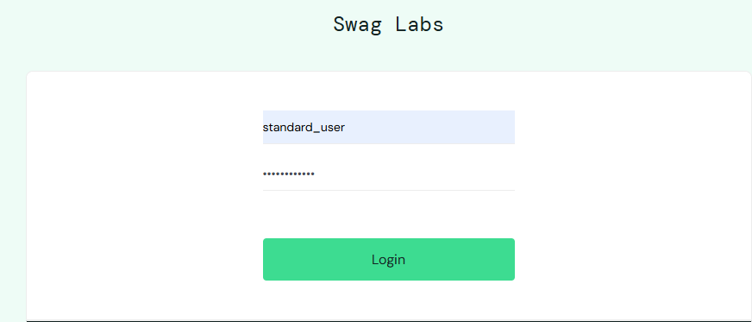

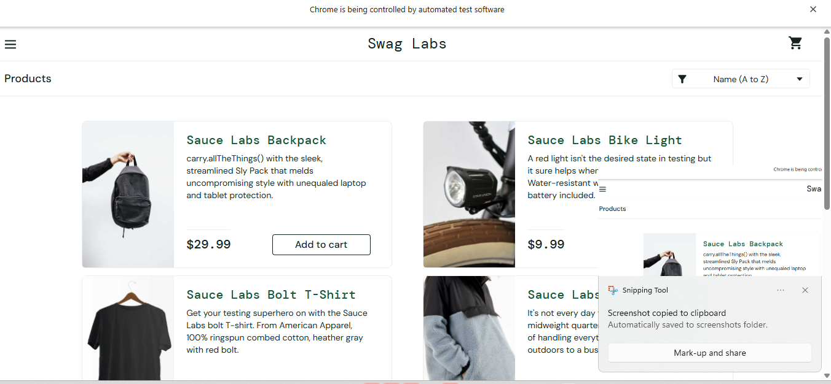

TC-02: Invalid Password

Input:

Wrong password

Expected Result:

Error message is displayed.

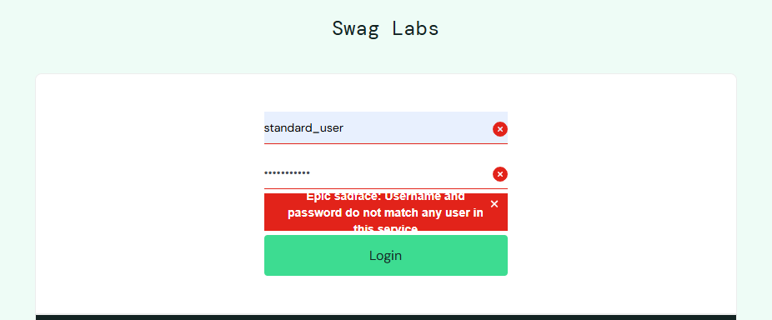

TC-03: Invalid Username

Input:

Wrong username

Expected Result:

Error message is displayed.

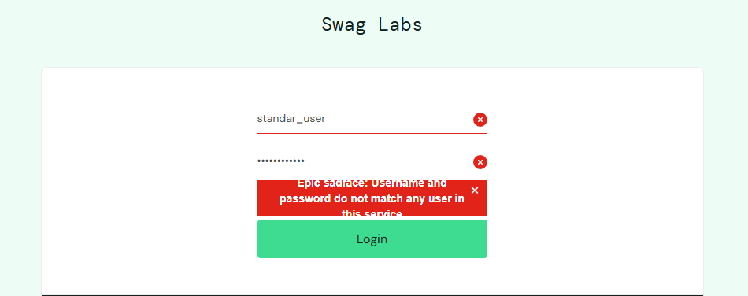

TC-04: Empty Credentials

Input:

Blank username and password

Expected Result:

Validation message is displayed.

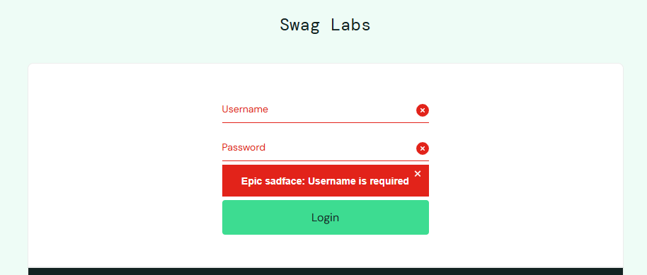

TC-05: Logout

Input:

Click Logout

Expected Result:

User returns to the login page.
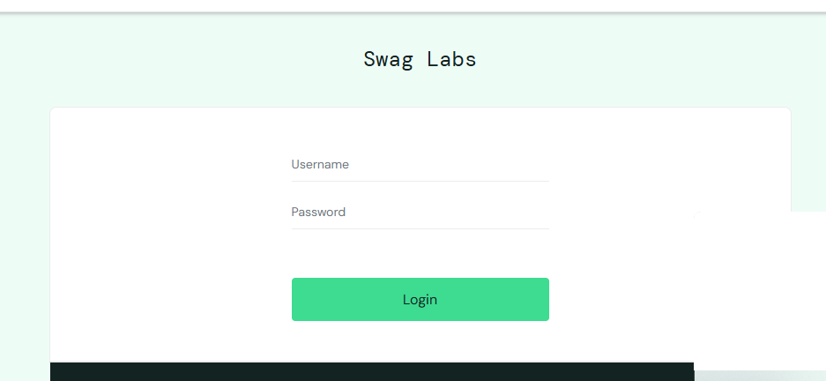

Source Code

from selenium import webdriver
from selenium.webdriver.common.by import By

driver = webdriver.Chrome()
driver.get("https://www.saucedemo.com/")

try:
driver.find_element(By.ID, "user-name").send_keys("standard_user")
driver.find_element(By.ID, "password").send_keys("secret_sauce")
driver.find_element(By.ID, "login-button").click()

assert "inventory" in driver.current_url
print("Login Successful")

except Exception:
print("Test Failed")

finally:
driver.quit()

Output

[SCREENSHOT 1:]

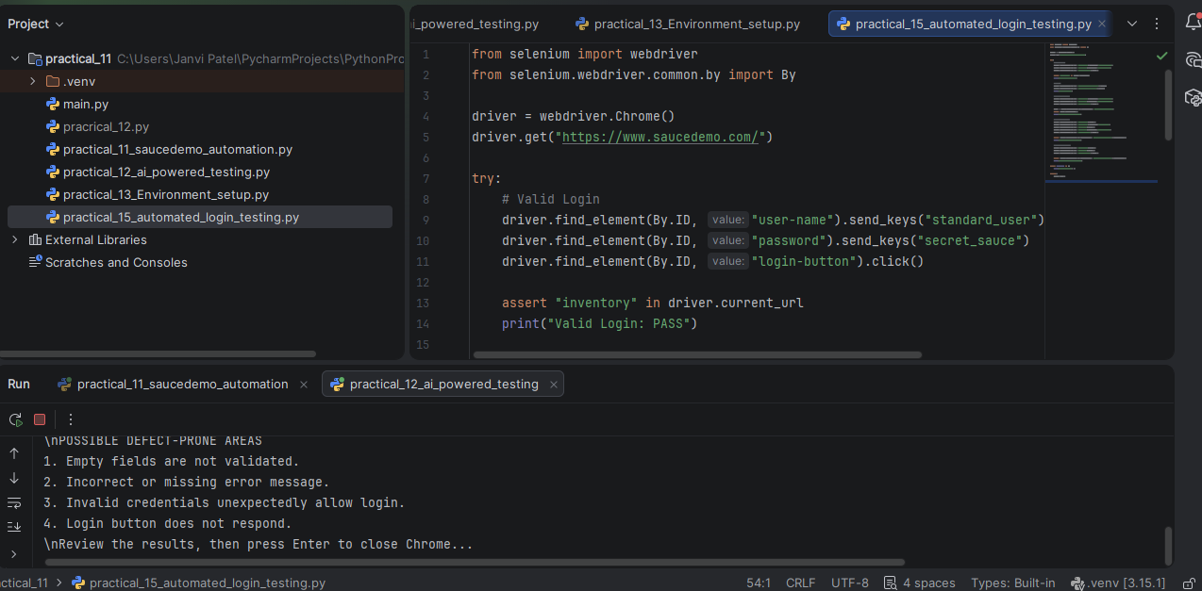

[SCREENSHOT 2: Paste the browser screenshot showing the Products page here.]

Conclusion:

Selenium successfully automates login testing and verifies the login result.

